Users

In this chapter I want to highlight some themes that emerged about the users of chemicals in the home, and to compare and contrast the users of garden chemicals, chemicals for cleaning the house and for developing photographs. The relationship between user and chemical is complicated. It includes regulators, retailers, manufacturers and their advertising agency, any number of committee members, sales staff and production line workers, copy writers whom may be users themselves. It involves the perception of other users through the media as well as word of mouth, or over the garden fence, where success, failure, news of accidents or misadventure colour how the user and the chemical interact. The user can behave in ways that seem at odds with messages they might be expected to receive from the influences outlined above, as well as any codified cues, warnings or instructions that they are not compelled to read or may not decipher in the intended way. Users cannot really be considered without non-users, ambivalence cannot be dealt with without the comparison to the well-informed. In this, the organic movement needs to be addressed and although they were not users of the herbicides I studied, the ethos that gardening could be done without industrial chemical products did percolate and can be seen in the decreasing numbers of chemical adverts in the media, as well as in the type or content of articles and letters printed.

## Children

Chemicals in the hands of children was seen as a particular problem; both with regards to accidents involving ingestion or mistaken identity so becoming an unwitting user, and when they deliberately obtained chemicals for their own entertainment, as an adventurous misuser. The tendency of young children to explore everything with their mouths, followed when they are older of a certain trust that contents of a container are always what they are expected to be, or at least safe, causes responsible adults to respond protectively and attempt to prevent accidents through appropriate chemical storage, supervision. When children, specifically 'adventurous boys'[1] are older, they may become interested in chemicals, though with the exception of photographic chemicals, generally not for the purposes they were intended for. Adolescents were behind banger and bomb making with sodium chlorate, the gateway having been opened through the gift of a chemistry set and facilitated by the ease with which further supplies could be obtained, either legitimately sold through shops or illicitly taken from the sheds of parents, relatives or neighbours. Solvent abuse is another area that adolescents are particularly attracted to, partly for the availability of substances in the home and partly for their low cost. Legislation has been enacted and enforced to protect children from themselves but only regarding sales. The availability of chemicals in the home and garden to be misused relies on education, whether through news reports of accidents or through workplace safety initiatives as well as school curriculum, all of which aim to alert adults and children alike to the hazards that could be found in homes.

The 1970s and 1980s saw a concerted effort to bring down accidents in the home, especially regarding children. Home Accident Surveillance System was initiated and collated results from hospitals around the country to help identify, better understand and address the types and reasons behind accidents in order to prevent them. The way that substances are listed is interesting. Under cleaning is the vague term 'chemical', along side chemicals caustic soda, ammonia, bleach (liquid and other, separated), and products by category such as lavatory cleaner, general cleaners, window cleaning fluid and oven cleaner. Products used in maintenance and DIY are similarly various; 'solvent' is listed with chemicals meths, surgical spirit, turpentine/ white spirit and paraffin, again alongside functional categories of products such as paint stripper. It shows that people were using chemicals as well as branded products, though those brands were not incriminated here.

CTC child deaths: one in 1947[2] and one in 1962.[3] In both instances, the six year old children had taken a rag soaked with the chemical to bed with them. The young boy had been cleaning his model train tracks with the chemical, and the paper described his fascination with the smell.[4]

Following an argument with his business partner, a young fish breeder killed two tanks of Japanese fighting fish by putting caustic soda and copper sulphate 'to be sure' that the fish were killed.[5]

Robert Cooke, MP for Bristol West, shared a number of personal experiences gained from chemicals used at his home, the large large country house Athelhampton Hall with grand gardens kept in order by gardeners, during a debate on the Farm and Garden Chemicals Act. He recounted how as a child he ate a whole box of “delicious” bran slug killer, and only found out what it was several years later when he asked the gardener what it was. He discovered his own young son carrying around a plastic tray of rat poison, and another time, playing with empty weedkiller containers.[6]

## Perverts

47 year old Marcus Mahoney's attack on 18 year old Linda Pike in her own home,[7] made all the more peculiar and awful by offering his own skin to be used for grafts that she subsequently needed.

Unnamed Industrial chemist brought home chloroform for domestic cleaning, and sexual arousal. His wife was killed when he overindulged and passed out, draping the towel soaked in chloroform across her face.[8]

## Model Users

Model users are a creation of the publishing and broadcast industries. By cultivating an authoritative gardening character, a respected regular feature (column or programme) can be a guaranteed to interest real and vicarious gardeners alike. They may not agree with the practices, but this can generate lively letters or further content if readers or viewers feel strongly enough to communicate these views. In the following section, the role of "celebrity gardeners", those who had public presence through newspapers and magazines, radio or TV, in setting an example and gaining acceptance for new chemical products is examined further.

Weekly gardening columnists modelled how to correctly use the chemical and broadcast a schedule for using the herbicide. The device of "jobs to do this week" is well used in their columns, which presents very similar advice and instruction on weeding, planting, fertilising as might be set out in gardening almanacs or books. The newspaper columns give the opportunity to add topical comment on rain or sun, or other events to supplement and fine tune the advice.

## Gender

Housework is generalised as being women's work, but this is not the case. Artist Joan Pilsbury shared housework with her husband Neil who she married in 1955, doing housework as it was needed to feel in order rather than by any rigid routine. Joan liked tidiness, but in her interview she didn't refer to hygiene, germs, ease, labour or time. Neil had been in the army and had his own flat before living with Joan, so he was used to looking after living quarters. Joan was the only interviewee in the BL collection of artist life stories who actually mentioned a cleaning product, the household disinfectant Izal, which she described Neil using in the yard and the kitchen.[9]

Robert Maguire remembered his mother's scrupulous housekeeping and that her daily routine was to polish the lino throughout the house before 10 am when she would go out shopping. He explained that it was just the way she had been brought up and continued to keep everything spotless her entire life. He did not say that he helped, and he did not reminisce about the polish, its smells, any effect, or how she might have done it other than saying that they did not have a vacuum cleaner.[10]

"What can be more tonal than the satisfaction which the grown up amateur or master of the house, enjoys when he returns from the city to his garden in the summer evenings, and applies the syringe to his wall trees, with refreshing enjoyment to himself and the plants and to the delight of his children who may be watching his operations."[11] Although the author of this scene did not mention what was contained within the sprayer, it could have simply been water to refresh the leaves in an industrially polluted area, the possibility of fascinating picture of domestic chemical use in 1838 as entertainment, not just care of plants, has been conjured up.

## Gardening as a gendered activity?

Garden magazines modelled the appropriate use of garden chemicals and even showed women involved in lawn care and general weeding, measuring out chemicals into a watering can and operating a flame gun. In the following six images showing a person waging war on weeds, rather than just the tools involved, four showed men.[12] This montage featured a gardener wearing a floaty, feminine dress and coiffured hair making up a solution of lawn treatment which was then applied by a man.

We can see that the advised best practice of making up the solution outside, rather than in the kitchen or utility room is modelled. Protective gloves are not indicated as necessary here. The smart dress of the 1963 lady gardener implied the absence of heavy gardening work and that the use of chemicals negated any need to dress down for dirty gardening because using chemicals was clean and easy. Similar photo sequences from the 1980s showed dedicated gardening clothes and protective gear, as well as using the product cap to measure out rather than a spoon that could find its way back into the kitchen.

Illustration 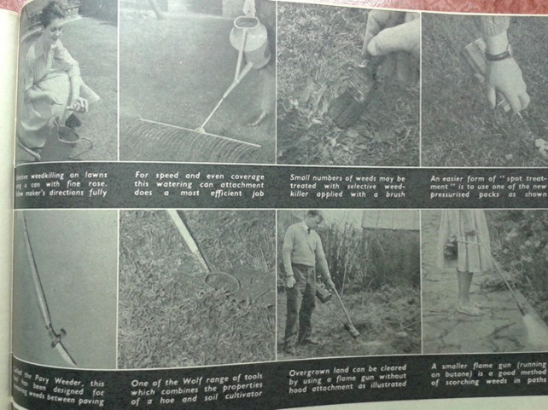1: Photo montage from "War on Weeds" Practical Gardening, June 1963, p65

Some gardeners wanted to use Weedol but not to invest in dedicated application equipment, so made do with items at hand, such as putting a large funnel over the watering-can rose to refine the spray accuracy.[13]

ICI even featured a celebrity gardener Percy Thrower in some of their adverts.[14] Thrower had been a household name since 1947, when he started giving gardening advice on BBC radio. His columns on the subject appeared in the *Daily Mail*, the *Mirror* and the magazine *Amateur Gardening*, he published books, as well as being lead presenter on the BBC television show *Gardeners World*. When ICI incorporated Percy Thrower's image and testimonial, they aimed to capitalise on Thrower's "brand" and the trust people had in him. I would describe Thrower as a model user or evangelist, a role taken on by other garden writers and broadcasters such as Cecil Henry Middleton's who was a horticultural consultant to Boots.[15]

Evangelists could also counter accusations that Weedol was expensive, by reiterating that by investing in the appropriate application spray bar, the herbicide could be applied without waste as the dedicated applicator could make Weedol go even further.[16] These model users were by no means perfect, shown through inconsistent product placement, or the occasional modelling of unideal opinions such as that "amateur packs were expensive".[17] Some newspaper columnists who evangelised about paraquat as an option for other home gardeners preferred mulching and cover planting to avoid weeds in their own gardens.[18]

With so many examples of careful and correct use to guide the application of paraquat in home gardens, how did paraquat come to be known as a killer chemical? What should be remembered is that the majority of paraquat users carefully followed the instructions for normal, expected uses and neither they, nor anyone else, came to any harm. A disobedient domestic user of Weedol would not store it in a safe place, they would allow children access to the granules, make up a stronger solution, or use the herbicide for purposes other than killing weeds in their garden. More seriously, careless Gramoxone users contained it in an inadequately labelled drinks bottle and allowed it into a domestic environment.

This reference to the master of the household points to gendered division of labour. He was expected to manage the fruit trees, vegetables and lawn, while the light work of tending flowers and weeding were allocated to women and children of the household.[19] However, an important part of the lawn care in addition to the manipulation of heavy machinery, was the identification and eradication of weeds. That this was undertaken by men is hinted at by the description of how "brain workers" would find the sense of achievement that could be gained from seeing the immediate visual impact of a session of weeding particularly beneficial, and the process of identifying weeds was even characterised as a stimulating, interesting activity.[20] These "brain workers" who were presumably involved in office based, long term projects and denied the satisfaction of a tangible result as part of their regular employment.

The ways that weeding could be approached was also described in gendered terms, which could be linked to the experience of work in the home and paid employment elsewhere. The concept that weeding was a task to be done in "odd moments" was one that garden writer Marion Cran espoused, and this meant that it could be regarded as costing nothing. I argue that this reflects women's experience of fragmented nature of modern domestic work, where automated processes of laundry or dishwashing may be set off, leaving the houseworker free for a limited period of time until the next stage of the process that requires human intervention comes around. Weeding undertaken by men on the other hand was something that had to be approached stoically and for extended periods of time, and this relates to the single minded focus that men are expected to exhibit in their paid work. The concept of hand weeding as expensive depends on how the person doing the weeding values their time. An unpaid housewife may appreciate the opportunity to spend a productive "odd moment" in the garden, choosing if she prefers, or if circumstances allow, to do a longer stint, whereas for a man used to approaching tasks for prolonged periods of time, applied to weeding this became a tedious chore, plus he knew the monetary value of his time. The readership of magazines such as *Amateur Gardener*, from where the example of weedkiller advertising was taken, was middle class gardeners who generally **'did for'** themselves. Perhaps the word "expensive" in this context was used ambiguously and could be read as simply time spent, or cash paid out to an employed gardener, which would worked to make the sentiment, and the product, relevant to both DIYers and employers of gardening staff.

While garden tasks requiring physical work with dedicated tools, heavy machines and chemicals might suggest the garden as a masculine space, this is would imply that the physicality, machines and chemicals required for housework would attract men to the task. Nonetheless, in garden manuals the sense of a male gardener is carried beyond the casual use of pronouns, and the desire for standardisation of measurements and aids for accuracy could hint at a masculine gardening task force, especially when compared to the more vague domestic measurements employed in handling chemicals used by women in laundering and general housework. We saw in the chapter on housework that women were dealing with "little lumps" of chemicals that may or may not have a comparable size to a roughly standard item such as a walnut.

While gardening books and manuals described masculine workers, in garden chemical adverts both men and women were featured but for different tasks. Women were not depicted as weeders, despite a history of low-paid work in this role. Adverts for weedkillers depicted men doing the lawn care and weeding, but this is not to say that women's use of chemicals was feminised or that they were not involved in the same battle against the ravages of garden pests. When adverts for other garden products are considered, female users signal the items' lightness, or simplicity of use. This can be seen most strongly in lawn mower adverts, but also in those for sprayers and chemical sprays. The appearance of women spraying the garden with chemicals means that they were chemical users, and they were killers of mites, aphids and fungi, but not of weeds. This division of labour occurs from the 1960s so coincides not just with the increasingly visible movement for gender equality, but also heightened awareness of the health effects of chemicals, especially on reproductively active women. In this respect, the female users can stand in for chemical safety but when lawn care chemicals are benign, women are not needed to denote safety.

Also significantly, the male figure employed is sensible, middling and stereotypical hapless male does not feature as he might if this was a product for use inside the home. It would not be fitting for "the horse's ass"[21] to model anything less than responsible chemical handling for a product that is meant to kill. The models employed by the advertising agency to portray gardeners would not be employed to promote underwear, or fast cars; he is paunchy, conservative and a home-oriented family man. He's capable, likes the (domesticated) outdoors but is not a rugged, macho character.

The visual trope of hand in a pocket signifying ease and leisure was picked up on by an artist for woman's magazine Good Housekeeping when they illustrated an article on choosing and using weedkillers. Her glasses were specifically pointed out as a protective measure, to protect her eyes from any wayward droplets,[22] her apron was not commented on. That it was left to magazines to translate the use of Weedol to women does not mean that women did not already choose or use this product, but it is interesting simply because of the absence of women and femininity from Weedol adverts.

The "Stand up to weeds!" advert was first placed in mid-April 1968, again only showing the lower half of a male user in neat trousers and a shirt, standing with a hand on his hip and holding a watering can with which to apply weedkiller.[23] The wording implies both the physical action of weeding, which with Weedol no longer involves bending or kneeling, as well as overcoming the relentless invasion of weeds in ones' garden. The practical poses that featured in Weedol adverts are in themselves masculine, they are not decorative or in anyway defying gravity in an unfeasibly unstable manner. which is often how women are illustrated or posed in advertisements for products, a subject that historian of advertising Roland Marchand has explored in depth.[24] If we take Zayer's typologies of masculinity depicted in advertising, the men shown in these advertisements are not adventurers, athletes, attractive, strong, wanting to stand out as individuals, daredevils, partiers or players. It would be unfair to categorise them as slobs (out of shape and unattractive) though resorting to a labour saving device could be seen as avoiding physical exertion, leaving the most appropriate typologies as goal-driven (determined and motivated to destroy weeds), and family men (working at home).[25]

Illustration 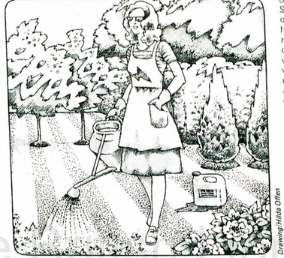2: Waging War on Weeds: a profoundly peaceful image of the war in this garden. The container beside her is not for domestic Weedol, it looks awfully like one for non-domestic Gramoxone.

Another theme that emerged was that of using chemicals at home was often done in solitude, which conflicts with the idea that skilled handling of chemicals was better learned in person, rather than from the printed page. In order to avoid dangers associated with chemicals this was how chemicals should be used, that housework should be invisible, that there was less chance of disruption and therefore poor results if a person worked alone in a darkroom. This isolation interrupted passing on knowledge about chemicals, making them more easily displaced by products deemed safer and therefore able to be used with less strict controls. Advertisements reflect an idea of what happens in real and may shape what users go on to do with that product.

The depiction of a lone person able to combat all the weeds in their garden thanks to chemical assistance is common in herbicide advertising. This also reflects the pursuit of gardening as something that could be pursued alone, or as a joint project.[26] Mass Observation diarist Nella Last often wrote about garden activities that she undertook alone, as well as those that she instructed her husband to do. Sometimes the Last's hired a young man to help with tasks while they worked with him in the garden. Gardening was not always a source of harmony, thanks to Will Last's tenancy to criticise his wife's efforts, but at various times they both undertook weeding duties. Herbicides were never referred to or named by Nella, who wished that they could concrete in the joins of the crazy path to cut down on the weeding.[27] However, companionable chemical garden care was also illustrated in Illustration 3 of a 1970s advertisement for Murphy's range of garden chemicals, which shows a husband and wife working together.

Illustration 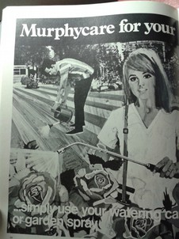3: Garden chemical advert showing typically gendered gardening: the man tends the lawn while the woman treats the roses. Unusually, the man is labouring, bent over, instead of at leisure.

The Lornox material illustrated below is not subtle; lawns were most often cared for by men, but Lornox is so easy, safe and simple to use that a woman can do it, even a child. In a rare example of the "like magic" trope, generally not applied to garden chemicals, this bottle of Lornox has become a pixie who has a miniature watering can to 'kill the weeds like magic' and energetically threaten the terrified weeds, much to the pleasure of the smiling grass, but the booklet's front page showed us in reality that a human would be doing the work.



Illustration 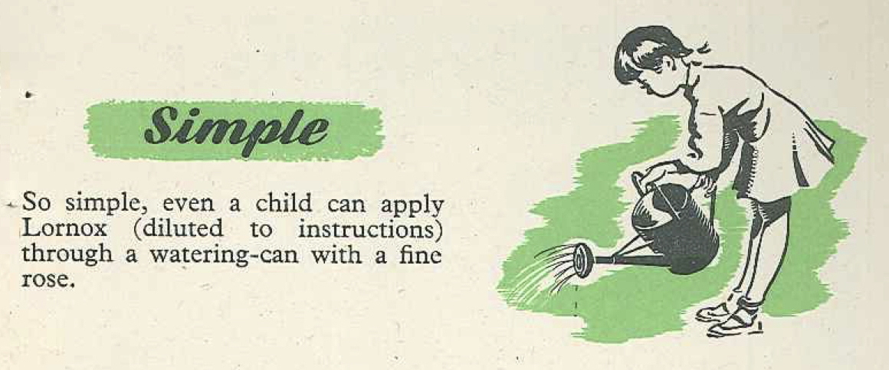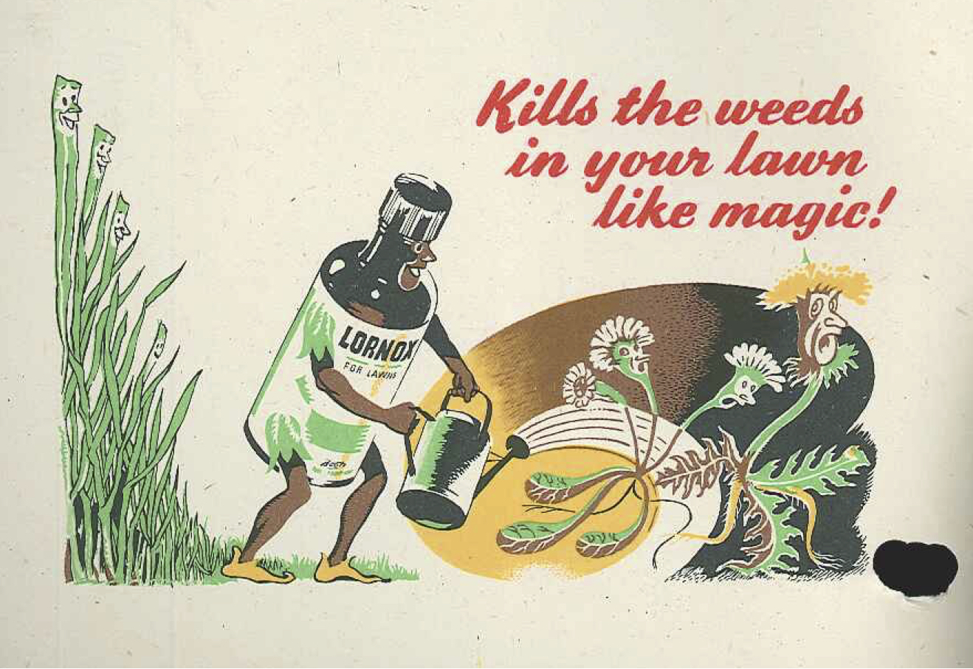4: Images from a 1948 promotional booklet showing the ease and overall simplicity of using this new chemical weedkiller from Boots.

(Boots Archive, Nottingham)

Contrary to what Jessamyn Neuhaus noticed in her study of housework in American advertising, where household cleaning products were regularly portrayed as anthropomorphised servants under the influence of the housewife, weedkiller advertising very rarely used this trope. Although it is hard to say from the illustrated hands and feet that appeared in weedkiller adverts that they were not those of a hired gardener, where a more complete image of the product user appeared they appeared leisurely rather than busy. In balance, that chemicals were not generally taking the place of hired help supports Constantine's notion that generally gardening was done by the home dweller. However, Lornox provides an exception to this rule, as well as the rule that children and weedkillers should be kept separate.

## Poisoners

The character of the paraquat misusers were described as adulterous, jealous men and women, in turbulent, unconventional relationships that made for grippingly sordid, salacious news. I say misusers, because not only were the poisoners themselves described in these terms, but their victims, the unwitting misusers of paraquat, also had these negative descriptions applied to them. Poisoning is often thought of as a method used predominantly by women as a method of despatch not reliant on physical strength,[28] but in the cases reported on in the newspapers it was used about equally by men.

## Prisoners

When hunting for stories about household chemicals, another domestic situation arose for consideration. While it is not homely and does not spring to mind as a safe, protective, environment, people live in prison for considerable periods of time, performing all sorts of domestic activities there. Befitting the setting these were stories of chemical misuse, though not always from the inmates. Prisoners made an escape bid using an 'ammonia spray' made from water and six bottles of 'toilet-cleaning bleach'; the mixture blinded a police dog.[29] An example given to demonstrate the vindictiveness of prison officers was of Harpic being poured into a fish tank that had taken years to establish.[30] A 42 year old man awaiting sentence for murder at Brixton prison used paraquat for the purpose of suicide, a rarity as asphyxiation or cutting were the most common, presumably as access to such poisons is usually unlikely.[31]

Solvent abuse

Related to this medicalised use as an anaesthetic, came an example of a misadventure with the chemical when used anaesthetically in domestic circumstances. Newspapers carried the story of the death in 1960 of Mrs Cobbett, a married woman pregnant with twins, who died after inhaling the chemical, as directed by her lover Leonard Pike. It emerged during the trial that he had supervised consensual and repeated CTC intoxications to at least one other woman.[32] The effect was described as similar to a 'couple of gins', but could completely knock a person out who would then be unaware of their surroundings or what was happening to them. Expert witness J. Payne reflected on the case, having interviewed Pike and found that he had learned to use carbon tetrachloride as an anaesthetic while in the Pioneer Corps, when he and a colleague carried out illicit abortions on young women in Aldershot. Pike had observed that during the induction of anaesthesia some women became sexually aroused, which Payne acknowledged as a little known property of quite a few anaesthetic compounds. It was from this medicalised experience that Pike came to use carbon tetrachloride as an aphrodisiac in a domestic setting.[33]

CTC was also used for cheaply achieving oblivion rather than this aforementioned aphrodisiac state.[34] Solvent abuse using a wide range of household substances had been prevalent since the 1950s, but only periodically came to public attention when a fatality or violent incident while under the influence of such a substance reached the news.[35] The low price and ease of accessibility meant that children in particular were prone to this use, and became the subject of sales restrictions for solvents generally. Even if a shopkeeper prevented the sale of solvents to a child, only their parents could attempt to control what happened with products already in the home. Author of a book of hints for the housewife, Leslie Keating, wrote in 1972 about the potential for this to happen, and advised readers to discourage their children from such behaviour as strongly as possible, which included keeping domestic cleaning solvents out of reach.[36] This type of warning, in a manual like this, is extremely rare. While general dangers of accidental poisoning were pointed out readily, deliberate misuse was a subject that did not appear in informative manuals or articles, only issue-led news reporting.

Disobedient users

John Forester, MP for Stoke on Trent and one of the supporters of the dangerous household product (child safety) bill, confessed that he sometimes decanted chemicals from their original container when he had bought a large, unwieldy quantity.[37]

Sally Oppenheimer, Minister for Consumer Affairs and who worked on the Dangerous Household Products bill in 1982, made her stance clear “I firmly believe that the main responsibility for ensuring that children do not swallow dangerous products must, in the first place, rest with the parents” although she acknowledged that they needed “the right information and advice as to the dangers”, provided in clear and consistent labelling. Education was a vital part of improving safety, symbols could be taught to children. Neil Thorne wondered why poisonous products were not sold in the distinctively shaped and textured bottles of his childhood. Although nobody answered his question in that debate, the preference for plastic bottles over glass and the ways that plastic bottles could be economically moulded meant that these useful signals were not replicated.

1. R. E, Parker. "Warning Needed." *The Times*  (19/08/1964) 11
2. "'Chloroform' Cleaner Kills Girl of Six." *The Daily Mail*, 02 July 1947.
3. "Smell Kills Boy Aged 6." *The Daily Mail*, 20 October 1962, 6.
4. "Smell Kills Boy Aged 6." *The Daily Mail*, 20 October 1962, 6
5. "Put Caustic Soda in Fish Tanks." *The Manchester Guardian (1901-1959)*, 1953 Nov 27 1953, 4.
6. Butler, Joyce, Peter Mills, Robert Cooke, David Mudd, and Anthony Stodart. "House of Commons Debate: Farm and Garden Chemicals." *Hansard* 821 (20 July 1971): cc1295-407.
7. "Weeping Man Hides from Scarred Girl." *Daily Express*, 06 December 1962, 14.
8. Allan, A. R., R. C. Blackmore, and P. A. Toseland. "A Chloroform Inhalation Fatality - an Unusual Asphyxiation." *Medicine, Science and the Law* 28, no. 2 (1988): 120-22.
9. Pilsbury, Joan. "National Life Stories Collection: Craft Lives." By Frances Cornford (01 November, 02 November 2012). 3 of 5, 53.01
10. Maguire, Robert. "National Life Story Collection: Architects' Lives." By Linda Sandino (2004). track 1 of 19, 27.00
11. JC Loudon "Suburban Gardener and Willa Companion" quoted in Holmes, Caroline. *New Shoots Old Tips*. London: Frances Lincoln, 2004. p25
12. "War on Weeds." *Practical Gardening*, June 1963, p65.
13. Turner, W. "Safer Weed-Killer Spraying." *Practical Gardening*, October 1966, p65.
14. “To get plenty of vegetables, I give them plenty of help”, Daily Express, 04.09.77, p22. "Fast and easy. That's how I get rid of weeds" Daily Mail, 16.04.77 p31. In both adverts, Percy is shown holding his pipe
15. Buchan, Ursula. *A Green and Pleasant Land: How England's Gardeners Fought the Second World War*. London: Hutchinson, 2013. Chapter 6
16. "Gardening" The Times, 16.05.70, p26; "Gardening" The Times, 04.07.70 p23
17. Take the backbreak out of weeding' Roy Hay, The Times, 17.06.67, p6
18. 'Take the backbreak out of weeding' Roy Hay, The Times, 17.06.67, p6 (this article predominantly about ground cover was adjacent to a Weedol advert); 'A case for ground cover.' Times [London, England] 1 June 1974: 13, Roy Hay. 'Covering a lot of ground.' Times [London, England] 15 June 1974: 12.
19. Holmes, Caroline. *New Shoots Old Tips*. London: Frances Lincoln, 2004. p21-22
20. Beale, Reginald. *The Book of the Lawn: A Complete Guide to the Making and Maintenance of Lawns and Greens for All Purposes*. London: Cassell, 1931. p78
21. Thomas, Kevin D. "Understanding Representations of Black and White Manhood in Print Advertising." *Advertising & Society Review* 14, no. 2 (2013).
22. "Waging War on Weeds." *Good Housekeeping*, July 1975, p110.
23. “Super Summer” Timothy Whites advert, Daily Express, 17.05.68
24. Marchand, Roland. "Advertisements as Social Tableaux." In *Advertising and the American Dream: Making Way for Modernity, 1920 - 1940*, 164-205. Berkley: University of California Press, 1985.
25. Zayer, Linda Tuncay. "A Typology of Men's Conceptualizations of Ideal Masculinity in Advertising." *Advertising & Society Review* 11, no. 1 (2010).
26. Bhatti, Mark, and Andrew Church. "‘I Never Promised You a Rose Garden’: Gender, Leisure and Home-Making." *Leisure Studies* 19, no. 3 (2000): 183-97.
27. Last, Nella, Malcomson, Patricia and Robert Malcomson () *Nella Last's Peace: The Post-War Diaries*
28. Watson, Katherine. *Poisoned Lives : English Poisoners and Their Victims*. London ; New York: Hambledon and London, 2004.
29. Longmuir, Harry, and Keith Colling. "Jail-Break Men Made Their Own Arsenal." *The Daily Mail*, 28 November 1972, 9.
30. Sale, Jonathan. "Inside Story of Life Behind Bars." *The Times*, 27 October 1973, 14.
31.
32. Fallows, George. "I Let the Gas Man Dope Me." *The Daily Mirror*, 18 November 1960.
33. Payne, J. "The Criminal Use of Carbon Tetrachloride." In *History of Anaesthesia Society Autumn Scientific Meeting*, 12-13. Chequer Mead Arts Centre, East Grinstead, 2003.
34. McQueen, Alastair. "Terror of the Teeny Glue Gangs." *The Daily Mirror*, 24 October 1979, 16-17.
35. Watson, Joyce M. "Clinical and Laboratory Investigations in 132 Cases of Solvent Abuse." *Medicine, Science and the Law* 18, no. 1 (1978): 40-43.
36. Keating, Leslie. *Stain Removal*. Hampshire: Kenneth Mason, 1972. p7
37. Forrester, John, Sally Oppenheim, John Fraser, and Neil Thorne. "House of Commons Debate: Dangerous Household Products (Child Safety) Packaging Bill." *Hansard* 16 (29 January 1982): cc1157-67.